# Custom cables for Invasive Blood Pressure

PRiME-PSA system needs to interface with Invasive Blood Pressure (IBP) transducers. Currently, only [Edwards TruWave transducers](http://www.edwards.com/eu/products/pressuremonitoring/pages/truwave.aspx) are supported. There are two sets of adapter cables necessary: IBP-to-PSA cables allow Edwards TruWave transducers to be plugged into the PRiME-PSA system, and PSC-to-IBP cables allow the PRiME-PSC system to be plugged into an external commercial recording system (such as Siemens Sensis or GE MacLab).

## IBP-to-PSA Adapter Cables

Two IBP-to-PSA adapter cables are necessary (one for each IBP channel). Each IBP-to-PSA cable requires one Edwards TruWave [mating cables](https://catalog.carefusion.com/vitalsigns/invasive-blood-pressure-cable-2021197-002.html) and RJ45 connector. The exact TruWave mating cable used is not important as only the gray circular connector is needed. The TruWave mating cables should be cut ~3-6 inches from the end of the gray circular connector. For the RJ45 connector, a single Ethernet UTP (unshielded twisted pair) patch cable can be cut in half (assuming a 1ft length). The Ethernet cable can then be spliced with the TruWave cable. It is recommended that the IBP-to-PSA cable be kept <1’ in length. If a longer cable is necessary, we recommend using an Ethernet coupler ([example](http://www.mouser.com/Search/ProductDetail.aspx?R=N033-001virtualkey54510000virtualkey545-N033-001)) to attach a longer Ethernet cable as needed. This allows the user to keep the total length as short as possible as circumstances warrant. Be sure to use a coupler with a plastic housing as this cable will be in the MRI room. While a standard Ethernet RJ45 connector is used, the cable should not be plugged into a normal Ethernet jack. The adapter cable uses pins which are typically unused in a standard Ethernet configuration which should limit damage if the cable is accidentally plugged into an Ethernet jack.

|  |  |  |
| --- | --- | --- |
| Ethernet Pin | TruWave Pin | TruWave Wire Color |
| 4 | 1 | Red |
| 5 | 2 | Green |
| 7 | 3 | White |
| 8 | 4 | Black |
| Unused | 5 |  |

## PSC-to-IBP Adapter Cable

The PSC-to-IBP Adapter cables requires two Edwards TruWave transducers and a single DB9 male connector (with housing).

1. Start with the full IBP package.

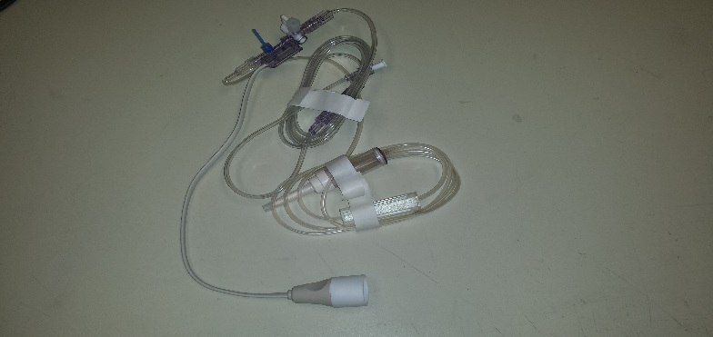

Figure . Full IBP transducer with tubing

1. The white cable of the transducers should be cut close to the semi-transparent plastic housing of the IBP transducers.

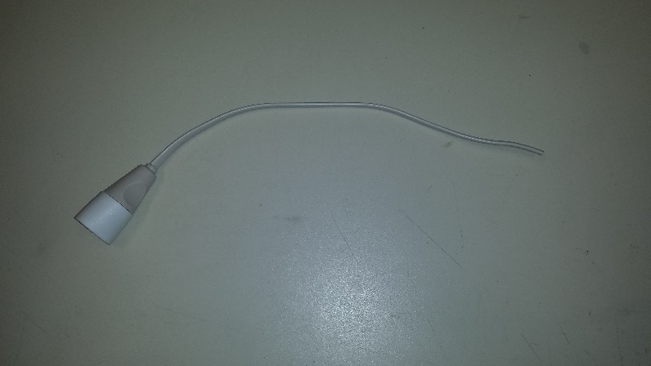

Figure . Electrical cable cut from transducer.

1. The wire needs to be stripped using thermal wire strippers to expose 5 solid copper wires. Thermal strippers are recommended as the cable is constructed of solid plastic which is difficult to strip using mechanical cutting tools (mechanical strippers, hobby knife, etc.) without damaging the ~30AWG solid wire.

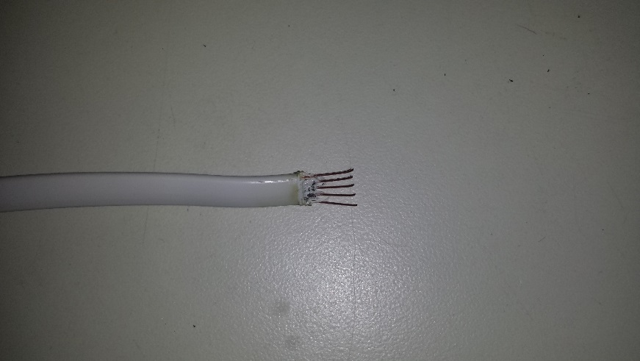

Figure . Transducer electrical cable stripped (using thermal stripper) to expose bare copper wire.

1. Once exposed, the solid wires are soldered to male DB9 connectors, using Pins 1-4.

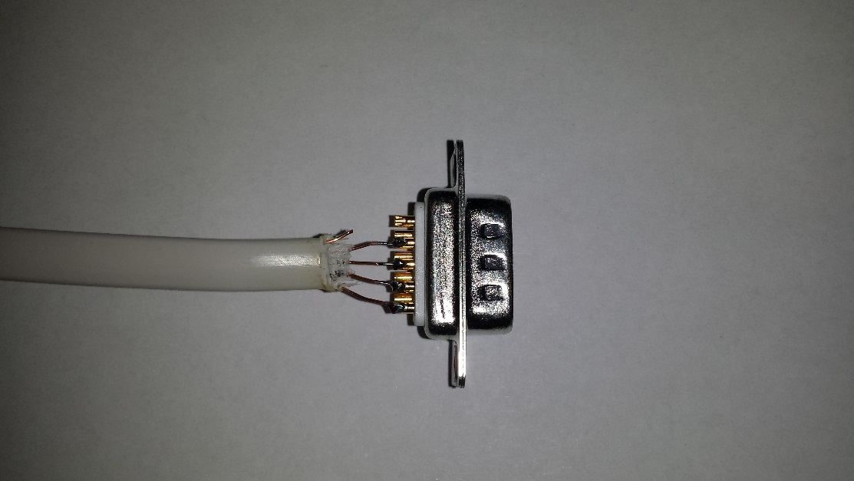

Figure . Transducer electrical cable soldered to male DB9 connector. Unused Pin 5 of transducers electrical cable is cut, but can be soldered to Pin 5 of DB9.

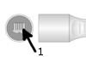

Figure 5. Edwards IBP Transducer connector with Pin 1 marked.

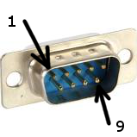

Figure 6. Male DB9 connector with Pins 1 and 9 marked.

1. Steps 1-4 are repeated for the second IBP cable, using pins 6-9 of the DB9 connector. A piece of heat shrink or electrical tape can be used to prevent the bare wires from the two cables from touching.

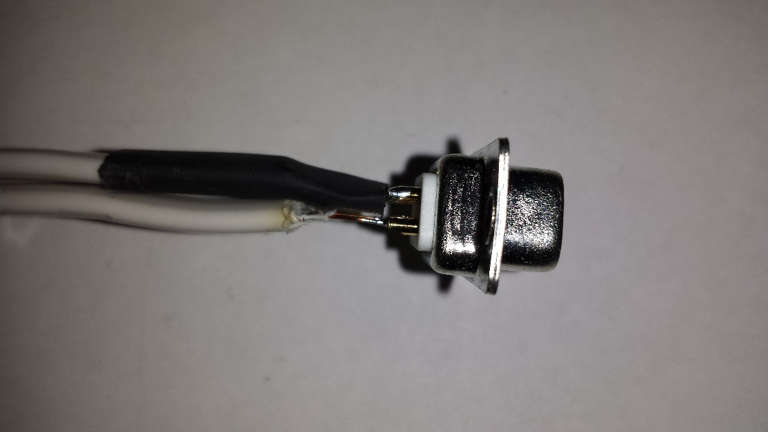

Figure . Second IBP electrical cable soldered to Pins 6-9 of DB9. Prior to soldering, heat shrink tubing can be placed on transducer electrical cable.

|  |  |  |
| --- | --- | --- |
| DB9 Male Pin | TruWave Connector | TruWave Pin |
| 1 | A | 1 |
| 2 | A | 2 |
| 3 | A | 3 |
| 4 | A | 4 |
| 5 | - | - |
| 6 | B | 1 |
| 7 | B | 2 |
| 8 | B | 3 |
| 9 | B | 4 |

Table 1. Electrical wiring connections for both TruWave IBP transducers to male DB9 connector.

1. Place cable inside DB9 housing and ensure the that strain relief applies appropriate pressure to the white cable (i.e., moving the white cable does no cause the wires near the DB9 connector to move).

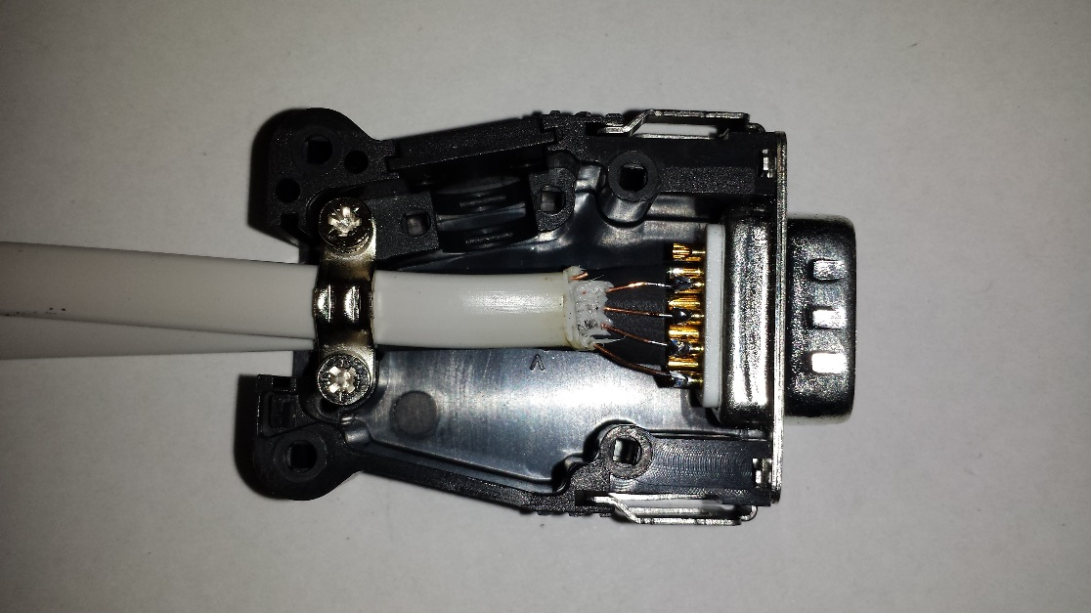

Figure . Both IBP cables are inserted into a plastic DB9 housing. Strain relief (metal clamp on left side) must be used to prevent motion of cables near DB9. Bare copper wires are very fragile and can break if bent.

1. Screw the housing cover and mark the white connectors as IBP1 and IBP2.

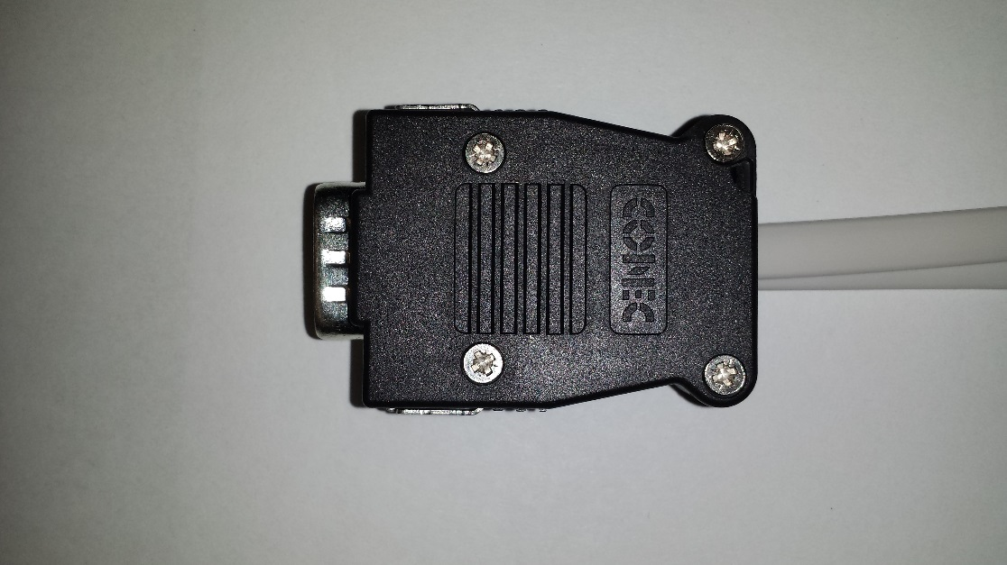

Figure . DB9 housing with cover attached.

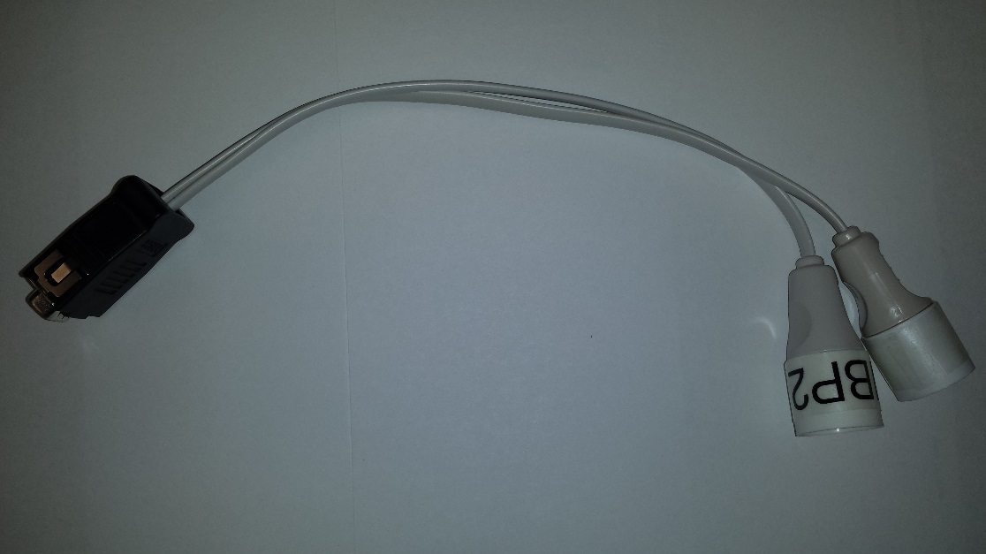

Figure . Full cable assembly shown. Stickers are placed on IBP connector to distinguish the two connectors (IBP1 sticker not visible in this photo).